Research Project Progress Report Week [2] – SIT723

|  |  |
| --- | --- |
| **Student Name:** | Satvik Sharma |
| **Supervisors’ Names:** | Prof. Maia Angelova |
| **Project Title:** | Financial Time Series analysis with machine learning |
| **SIT723 Target Grade:** | Distinction |
| **Overleaf Project Link:** | <https://www.overleaf.com/7593645898fsydrtqsdgzb> |
| **Project Folder Link:** | [*https://deakin365.sharepoint.com/:f:/r/sites/SIT723-FinancialTimeSeriesAnalysiswithMachineLearning/Shared%20Documents/General/Satvik%20Sharma(218595095)?csf=1&web=1&e=Aqw8K8*](https://deakin365.sharepoint.com/:f:/r/sites/SIT723-FinancialTimeSeriesAnalysiswithMachineLearning/Shared%20Documents/General/Satvik%20Sharma(218595095)?csf=1&web=1&e=Aqw8K8) |
| **Worklog:** | [*https://deakin365.sharepoint.com/:x:/r/sites/SIT723-FinancialTimeSeriesAnalysiswithMachineLearning/Shared%20Documents/General/Satvik%20Sharma(218595095)/Worklog.xlsx?d=w2cfbd3ab588d42f58966474ef14f85c2&csf=1&web=1&e=v7A91f*](https://deakin365.sharepoint.com/:x:/r/sites/SIT723-FinancialTimeSeriesAnalysiswithMachineLearning/Shared%20Documents/General/Satvik%20Sharma(218595095)/Worklog.xlsx?d=w2cfbd3ab588d42f58966474ef14f85c2&csf=1&web=1&e=v7A91f) |
| **Project Plan** | |
| **Summary of the work planned with your supervisor:** | For the project prototype, I had to choose a dataset which should be big enough and should consist the financial aspect. Moreover, research about machine learning algorithms from the articles and the books available for the literature review and further analysis. |
| **Summary of the work done:** | I chose 20-year dataset of nifty-50, a stock exchange benchmark for the machine learning. I read and reviewed 25-30 published articles and started working on the literature review. Moreover, I looked upon some of the machine learning algorithms. |
| **Next steps:** | The literature review draft will be reviewed and fixed for the final version. Further, I looked upon some of the machine learning algorithms which would be helpful in analysing the financial time series for the 10-year dataset and predict for 1 year in future and more. |
| **Overall project progress:** | Overall, the project is going according to the deadline and I am happy with the current progress. If this continues, I will be able to finish the project on time |

# Reflection against Assessment Rubric

Add comments and evidence against your target grade for each criterion in the assessment rubric. You should also provide evidence (relevant to your target grade) on how you meet all the relevant criteria for that grade based on your progress so far.

*In case you have not started work on a specific criterion, e.g., research evaluation, leave it blank.*

|  |  |
| --- | --- |
| **Your reflection on work done so far against the assessment rubric criteria** | |
| **Literature Review** | Distinction |
| **Technical & Academic Writing** | [Add your comments, grade and relevant evidence here] |
| **Research Design** | [Add your comments, grade and relevant evidence here] |
| **Project Management** | Distinction |
| **Artefact Development** | [Add your comments, grade and relevant evidence here] |
| **Research Evaluation** | [Add your comments, grade and relevant evidence here] |
| **Research Dissemination** | For the initial two weeks, I had to familiarise myself with the topic of the project and with machine learning. Moreover, I reviewed a lot of research papers for the literature review, along with finding the appropriate dataset for machine learning, as well as researching different algorithms which are used for financial time series analysis. |
| **OVERALL** | I believe the work I done in the second week should add up to a distinction grade. |

## Additional Evidence

Add any evidence that supports your case for your target grade. For example, screenshot of git commits log, screenshot of your cloud storage folder, progress in your research report or artefact development, or a visual chart to illustrate project progress so far.

Worklog

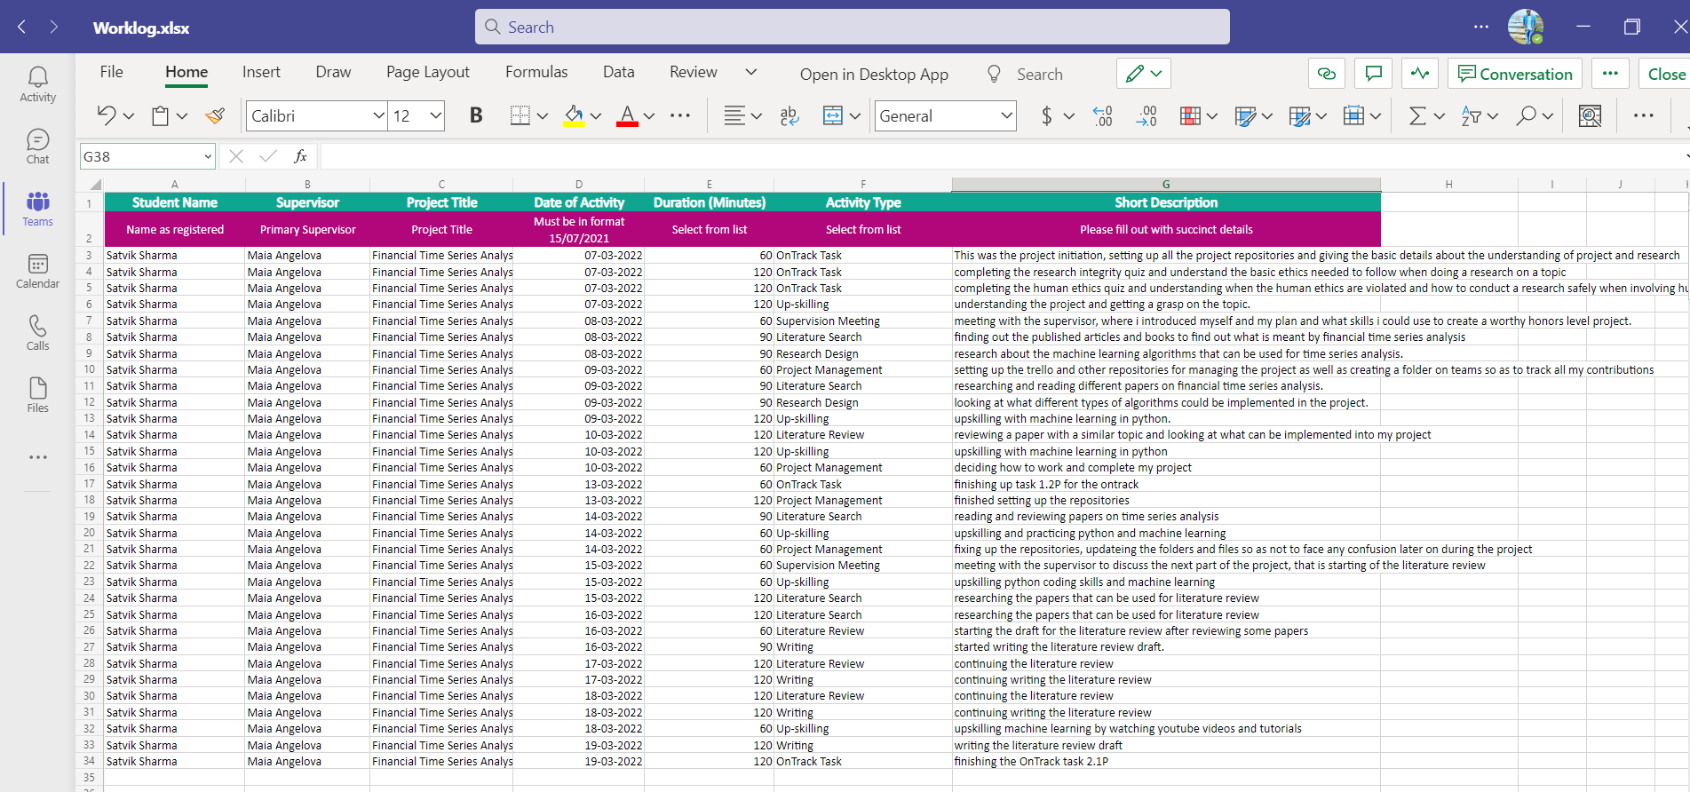

Trello

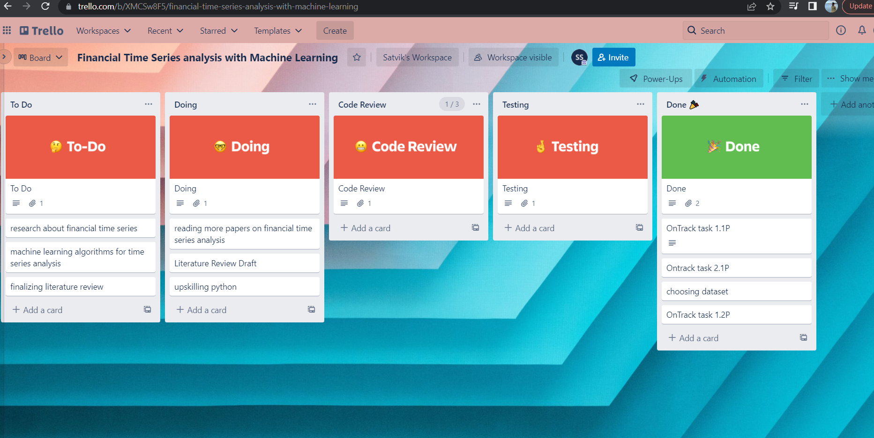

Project folder

